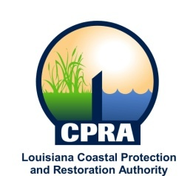

2013 Public Meetings

Garrett Graves, Chairman of the Coastal Protection and Restoration Authority, and Executive Assistant to Governor Bobby Jindal for Coastal Activities has announced the public meetings schedule for the Coastal Protection and Restoration Authority and the Governor’s Advisory Commission on Coastal Protection, Restoration and Conservation. Details on each meeting will be sent out at a later date. The dates and locations of these meetings are subject to change

CPRA
January 22, 2013
Lake Charles, LA

February 20, 2013
Baton Rouge, LA

March 27, 2013
Morgan City, LA

April 17, 2013
Baton Rouge, LA

May 15, 2013
Baton Rouge, LA

June 19, 2013
Baton Rouge, LA

July 17, 2013
Slidell, LA

August 21, 2013
Dulac, LA

September 18, 2013
New Orleans, LA

October 16, 2013
Baton Rouge, LA

December 3, 2013
Baton Rouge, LA

Governor’s Advisory Commission
February 26, 2013
New Orleans, LA

April 4, 2013
Baton Rouge, LA

June 6, 2013
Baton Rouge, LA

August 7, 2013
Abbeville, LA

October 2, 2013
Lafitte, LA

December 10, 2013
New Orleans, LA

